**Lecture 1 (3-18)**

**SUPER COMMUNICATOR BASICS**

1. Lead with the conclusion

* President of United States
* Information soaked society

1. Use big sparingly

* Orator. Highly educated preacher loves to use big words
* Big vocabulary tends to do better professionally
* Most audiences, other than academic elites, find these words off putting.

1. Combat jargon words (Industry specific term)

* Membership in a private club
* Safe within that circle
* Lawyer uses some terms related to their job which makes it hard for the non lawyers to comprehend.
* Not doing intentionally but keep an eye on that.
* Often used by marketers to mislead
* Replace with commonly used terms

1. Acronyms Drowning in alphabet soup (Short form):

* NASA other scientific / technical organization has endless stream of acronyms
* Someone from Climatology cannot understand
* Makes the specialized material more difficult for non specialist.
* Use judgement when to use and when not. Even if the acronym is spelled once at first it makes the audience to struggle reading

1. Shorter Sentences, Shorter Paragraphs, Shorter Chapters

* Long ones appear more educated but it is big like roadblocks for readers. Because of the internet.
* Too many short sentences is also a problem.
* Variation is the key mix it up.
* Don’t sacrifice the quality of writing.

1. Develop contents that sync with your audience’s culture

* Know the audience and their culture
* Americans like the information upfront with out much beating around the bush but chilean might like greetings (throwing in flowers) and stuffs.
* These cultural differtences might not exists only when travelled 1000 miles but can exists from place to place.
* Find the culture of the audience.

1. Make it Error Free

* Basic communication 101
* It makes you content less authentic.
* Destroy your credibility
* Always proof read
* Get checked by a third person

Reader-Centered Writing

Can be reader/writer centric,

Writer:

* Journals and diaries
* Schoolwork is somewhat

Reader:

* Technical communication

Use following guidelines

Who is my target Audience?

* Internal/External
* Upstream/Downstream

What’s their perspective on the topic, on me and the document I will write?

* Their expectation
* Goal of this document
* My role and relationship to the readers.

What is my goal or purpose in writing to these readers?

* What am I trying to communicate?
* Outcome for the readers.
* Clear understanding of your audience is very important.

Professional Tone:

* Tone refers to the attitude of the document.
* Technical comm. Avoids displaying an obvious emotion and strives for a neutral tone.
* Formal tone usually suits the expersts and scholars in the field seeking comple information
* Business writing might be less formal but not colloquial.

Writing constructively:

* Negative and constructive
* Finding the appropriate tone involves understanding your purpose, context. It involves an understanding the workplace hierarchy.
* Always use constructive or positive tone
* Peer review is helpful in this
* Adopt an adult to adult approach : avoid talking down on your reader.
* Be genuine : apologize if made a mistake, takes responsibility, be authentic
* Focus on positive: always focus on positive. What you can do etc
* Be courteous: Focus on the reader. Use ÿou”unless you are blaming. Use gender-neutral

**BECOMING A TEAM**

**What really mattered was less about who is on the team**

**And more about how the team worked together.**

1. Pyshological safety: Team members feel safe
   1. Take risks
   2. Vulnerable in front of other
   3. Not feeling embarrassed or in competent in front of the team
2. Dependability:
   1. Team members are dependable
   2. Quality of work done on item.
3. Structure and clarity:
   1. Know who is responsible for what
   2. Understanding the individual goals
   3. And the path to fulfill the expectation.
4. Meaning:
   1. Sense of purpose
   2. Your work is important for the team members and the growth of the team
5. Impact:
   1. Team members think your work matters
   2. Creates a change and move closer to the organization goal

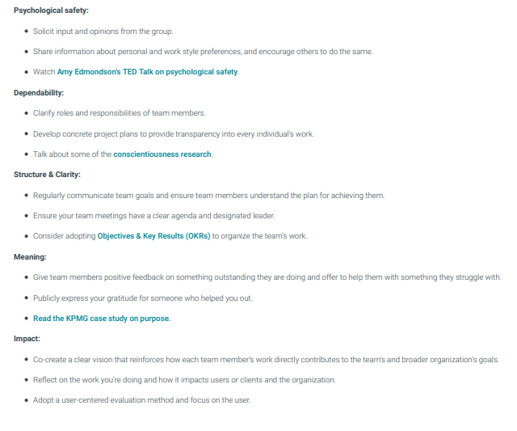

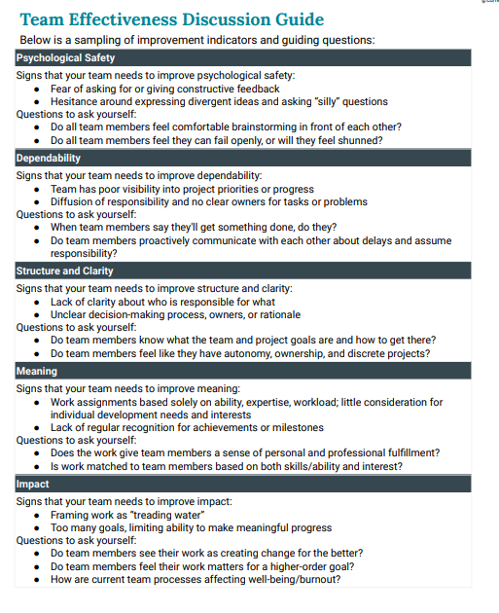

**Lecture 2: Overcoming presentational fear and optimize job application**

What does anxiety look like?

* Infer your confidence
* Hands in pocket
* Anxious
* Stuttering words (cognitive demand of speaking with Anxiety)

How to appear less Anxious?

* Fake it till you make it
* Work on presenting confident as possible

Eye Contact:

* Confident
* Confident People maintain eye contact with the audience.
* Eyes are the windows to the soul.
* Try to watch the space between the eyesbrows. Once comfortable spread the eye contact around
* Image the group as sector. Once you grab the attention from one sector move on to the another

Stance, Posture and Movement:

* What not to do

1. Don’t stand still and keep hands in the pocket.
2. Quies for not being confident

* What to do

1. Try to walk around but not so much
2. When moving don’t walk completely facing the left and right wall.
3. Walk in 45degree angle.
4. Make a stance by placing a leg forward.
5. Take up the space will show confidence. Show you are poweful and persuasive.

Gestures:

* Connect with the audience
* Reach to you audience.
* Extend your arm and elbows whe you are gesturing
* DON’T script gestures.
* Use descriptive gestures

Voice:

* Voice is supreme when important in online meeting or webinars.
* Audience attention can easily wander
* Use emotive words. Show exactment, valuable and challenging, Give meaning to just by using appropriate word.
* Reading out loud helps.
* If it is awkward play some background musing
* By doing to so it will increase you vocal stamina.
* Support your voice with proper breathing.
* Use apps on your smartphone and find variations in the tone.

Fixing vexing verbal and vocal issues:

* I think, Sort of and Kind of helps in personal communication appear less dogmatic.
* But in public presentation it makes you look wishy washy.
* I believe, one way can be used instread
* Tag questions may occur like saying something and asking for validation like “isn’t it”. In public speaking it diminishes your ability.
* Avoid disfluency by practicing “um’s” and “uh’s”
* Have a friend spot when you use disfluency.
* Practice inhaling and exhaling. Always complete the sentence by exhaling.

Technical Sentences:

1. Find the real verb
2. Find the real subject
3. Edit for clarity
4. Edit inclusive language
5. Check the grammar and mechanics

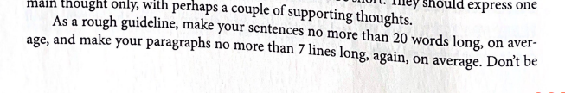

Find the real Subject:

* Subject should appear at the start of the sentence.
* Be direct as possible.
* Ask questions like what is the sentence really about?
* What is the real driving action.

Use active voice

* Subject performs the action precedes the verb.
* Passive voices writng faceless and frustrate readers.
* Make active fault your default.

Use passive voice:

* When you don’t care about the agent
* don’t know the agent.

Building was erected in 1960 (we don’t care about who)

Address Readers directly:

* address the readers using you.
* If you don’t you sentence might turn passive

Use simple language

A decreased number – fewer

Large number – many

Avoid redundancies

Edit for clarity

Use simple language

Avoid Jargon

Check grammar metrics

**Lecture 3: Information Efficiency**

Science of strong business writing

Simplicity:

* Keep it simple
* Short sentences
* Familiar words
* Clean syntax

Specificity

* When we hear more specific ones like tastes, feel and see. The simulation enxtend to our muscles too.

Surprise:

* Our brains are wired to make predictions.

Stirring language:

Smart thinking:

* Giving them a aha movement to please the readers

Social content:

Story telling

**Communication with Precision**

**The importance of wrting with reader in mind now the writing itself.**

**The seven C’s of professional writing**

1. Clear

* Know what you want to say before,
* Poor planning leads to confused readers.
* Match with vocabulary of audience

1. Coherent

* Reader can easily follow your ideas.
* Lead logically to the next.
* Writing lacking coherence are often choppy

1. Concise

* Write using least words possible.
* Avoid unnecessary padding and awkward phrasing.
* Use active verbs
* Think of the word count like a budget

1. Concrete

* Precise language to understand your ideas.
* Try to provide examples to your ideas if you are explaining abstract.

1. Correct

* Use grammar and punctuation correctly.
* Avoid vague terms like big or good try to get readers see your ideas.

1. Complete

* Include all the requested and relavant answers to the questions

1. Courteous

* Use appropriate language.
* Prepare easy to read document

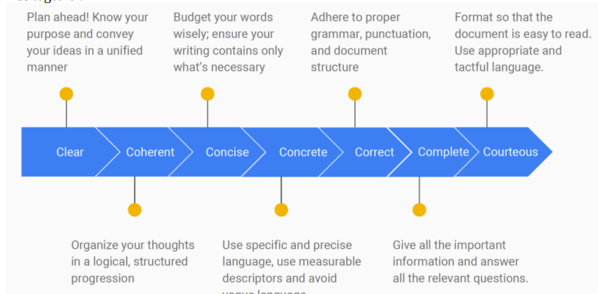

Sentence variety and length:

* Don’t overdo the variation

Precise wording

* Replace abstract nouns with verbs
* Prefer short words to long words and phrases
* Avoid clichés
* Prefer active voice

**Lists:**

1. Include: 2-8 items no more than 8
2. Try avoid splitting the list to two pages
3. Avoid overusing
4. Ajust the spacing
5. Capitalize the first letter of each item
6. Never use heading to indroduce a list

Types:

* Bullet list: if order is not a concern
* Numbered list: if order is required
* In-Sentence List: use when you want to maintain sentence structure.
* Labelled Lists: Provide some explanation and amplification
* Nested list; listed items have sub list.

Start with a verb indicating what the reader should do.

**Lecture 4: Presentation Slides**

10 Nonverbal Cues That Convey Confidence At Work

1. Good eye contact:

* It shows your level of involvement, interest
* Look directly into people eyes for 2-3 seconds before looking

1. Confident handshake:

* Always put your hand out for handshakes.
* Good handshake Full and firm handshake
* Treat men and women equally when shaking hands

1. Effective gestures:

* Be genuine
* Let your gesture speak the word for you.
* Avoid finger-pointing and fidgeting tapping, playing with hair etc.

1. Dressing the part:

* Clothing speaks volume
* Well -tailored garment speaks professionalism
* Avoid showy accessoriesm tight garments and revealing neckings
* Atleast wear a jacket

1. Authoritative posture and presense: Take up space

* Keep some distance between the legs.
* Stand up tall and straight, shows self assurance, authority and energy
* Good posture provide an attitude of leadership.

1. Appropriate facial expression:
2. Initiateing interactions
3. Appropriate voice toneL
4. Giving your full attention
5. Responding to others non verbal cures:

**Principles of visual design**:

Joshua tree story to show the importance of naming

The four basic Principles:

1. Contrast:
   1. Avoid elements on the page that are similar
   2. Keep content apart
   3. The most important aspect of the page, It is what keeps the readers attention
2. Repetition:
   1. You can repeat the colors, shape, textures, fonts etc
   2. This strengthens the unity.
3. Alignment:
   1. Nothing should be placed arbitrarily
   2. Every element should have a visual connection,
   3. This creates a clean and sophisticated look.
4. Proximity:
   1. Items relating to each other should be grouped close together.
   2. When elements placed together they become a common unit

**Stimulating**

Figures and tables:

* They are like illustration shows stories.
* They help the reader understand the complicated trends or visualize trends.
* It is not a replacement for text

Give numbered caption

Refer the caption number within the body text and discuss

Label all units

Provide source of the data and visual if taken from elsewhere

Avoid distorting images

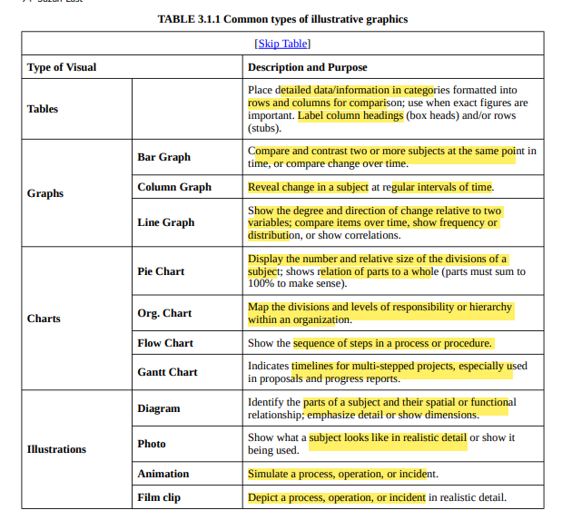

**Simplification**

**Cursed with knowledge**

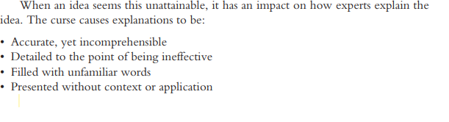

John explain virtualization

1. Do not make assumptions about what people already know
2. Use the most basic language possible
3. Zoom out and try to see the subject from the bradest perspective possible.
4. Forget the details and exceptions and focus on big ideas
5. Be willing to trade accuracy for understanding
6. Connect the basic ideas to ideas the audience understands